

Centre for Development of Advanced Computing, Mumbai



**Submitted by:**

Project Team 8

Yogita Khatavkar

Anushka Umbre

Pritam Powar

Shreya Singh

Yukti Pant

**Mr. Prathmesh Shivaji Dalve**

Project Guide

**1 INTRODUCTION**

“Walmart is an American multinational retail corporation that operates a chain of hypermarkets, discount department stores, and grocery stores”

The company has 45 stores across the United States. Every year the company runs several promotional markdown events before prominent holidays like Super Bowl, Labor Day, Thanksgiving, and Christmas to increase sales.

One of the leading retail stores in the US, Walmart, would like to predict the sales and demand accurately. There are certain events and holidays which impact sales on each day. There are sales data available for 45 Walmart stores. The business is facing a challenge due to unforeseen demands and runs out of stock sometimes, due to the inappropriate machine learning algorithm. An ideal ML algorithm will predict demand accurately and ingest factors like economic conditions including CPI, Unemployment Index, etc.

**Technology used - Python (ML), AWS, Spark, Data Visualization (Power BI)**

* 1. **Project Goals and Background:**

Walmart runs several promotional markdown sales throughout the year on days immediately following the prominent holidays in the United States; it becomes crucial for the organization to determine the impact of these promotional offerings on weekly sales to drive resources towards such key strategic initiatives. It is also essential for Walmart to understand user requirements and user buying patterns to create higher customer retention, increasing their demand adding to their profits. The findings from this study can help the organization understand market conditions at various times of the year and allocate resources according to regional demand and profitability.

The analysis for this study has been done using Python (ML), Big Data (Spark and Hive), AWS and Data Visualization (Power BI) on the dataset. The modeling, as well as the exploratory data analysis for the research, have been performed in Python, aggregation and querying will be performed using Hive and the final dashboard has been created using Power BI.

**1.2 Dataset:**

Conventional retail stores still play a prominent role in a world dominated by Ecommerce. Retail is the process of selling consumer goods or services to customers through multiple channels of distribution to earn a profit. From groceries to clothing to electronics, customers keep flooding the gates of retail stores to satisfy their needs. As time has passed, retailers have had to evolve in order to keep up with changes in demands and the ever-changing mindset of customers. One such retail industry juggernaut that has kept up with the demands of customers as well changed the face of the retail industry for the better is Walmart Inc.

Walmart Inc is an American multinational retail corporation that operates a chain of hypermarkets, discount department stores, and grocery stores, headquartered in Bentonville, Arkansas. They have many stores across the globe and it is the largest retail company by revenue.

We have historical sales data for 45 Walmart stores located in different regions. Each store contains a number of departments. Apart from these, weekly data of Fuel price, Holiday, Temperature with some other features are also present in the data set.

In addition, Walmart runs several promotional markdown events throughout the year. These markdowns precede prominent holidays, the four largest of which are the Super Bowl, Labour Day*,* Thanksgiving, and Christmas. The weeks including these holidays are weighted five times higher in the evaluation than non-holiday weeks.

Data consists of 421570 records of weekly sales from stores spanning between ’05-Feb- 2010’ to ’26-Oct-2012’. This comprises of 143 Weeks of sales data.

The datasets contain historical sales data for 45 Walmart stores in the United States along with store information and regional activity from 2/5/2010 to 11/1/2012. There are 3 csv files: stores, sales, and features.

The variables are described below:

**stores.csv**

This file contains information about 45 Walmart stores and includes the following fields:

**Store** – the store number

**Type** – the type of store (A, B, or C)

**Size** – the size of store in square feet

**sales.csv**

This file contains 421,570 Walmart’s historical sales records from February 5th, 2010 to November 1st, 2012 and includes the following fields:

**Store** – the store number

**Dept** – the department number

**Date** – last day of the week

**Weekly_Sales**

Weekly sales for the given department in the given store

Negative if returns exceed sales

Positive if sales exceed returns

**IsHoliday** –

True if special holiday falls within the week; otherwise, False

**features.csv**

This file contains 8,190 records related to the store, department, and regional activity for

the given dates and includes the following fields:

**Store** – the store number

**Date** – last day of the week

**Temperature** – average temperature in the region in Fahrenheit

**Fuel_Price** – weekly average fuel price (USD)

**MarkDown1-5** – anonymized data related to promotional markdowns that Walmartis running. MarkDown data is only available after Nov 2011, and is not available for all stores all the time.

**CPI** – consumer price index

**Unemployment** – weekly average unemployment rate

**IsHoliday** – True if holiday falls within the week. False if holiday does not fall within the week.

**2 PROBLEM STATEMENT**

There are many seasons that sales are significantly higher or lower than averages. If the company does not know about these seasons, it can lose too much money. Predicting future sales is one of the most crucial plans for a company. Sales forecasting gives an idea to the company for arranging stocks, calculating revenue, and deciding to make a new investment. Another advantage of knowing future sales is that achieving predetermined targets from the beginning of the seasons can have a positive effect on stock prices and investors' perceptions. Also, not reaching the projected target could significantly damage stock prices, conversely. And, it will be a big problem especially for Walmart as a big company.

* 1. **Objective:**

My aim in this project is to build a model which predicts sales of the stores. With this model, Walmart authorities can decide their future plans which is very important for arranging stocks, calculating revenue and deciding to make new investment or not.

This project studies Walmart’s historical sales data for 45 stores in the United States to assist Walmart’s management team in the decision-making process by:

Performing exploratory data analysis and time series analysis of Walmart’s sales data.

Identifying the factors that impact sales.

Developing machine learning models to forecast Walmart’s future sales.

**3 DATA PREPARATION**

**Missing Values:**

There are no missing values in store data.

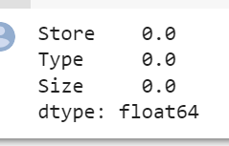

There are seven columns that contain missing values including MarkDown 1-5, CPI, and Unemployment. Since most missing values exist because there was no information available at a specific time, fields containing missing values are left as ‘NA’. The table below lists columns that have missing values along with statistics:

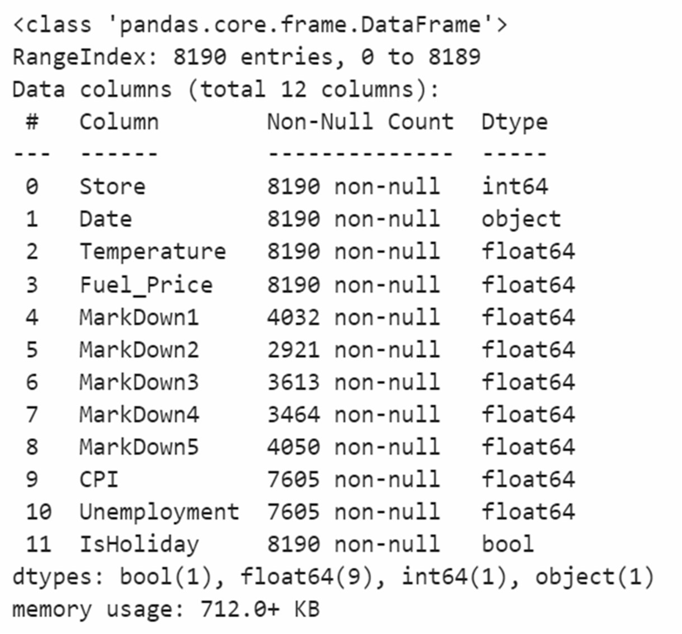

There are no missing values in sales data.

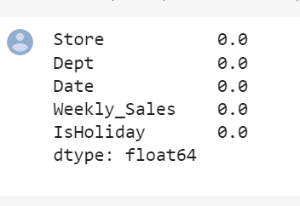

**New Columns:**

The following variables have been added to the dataset:

Total_MarkDown = sum of MarkDown1-5

Year = year extracted from Date

Month = month extracted from Date

Week = week of year extracted from Date

**Outliers:**

There are 9 columns that have outliers: Num of Depts, Dept Weekly Sales (Thousand), Temperature, MarkDown1-5, and Unemployment. Since outliers may contain important information, no outliers have been removed from the table.

**One-Hot Encoding:**

One hot encoding is one method of converting data to prepare it for an algorithm and get a better prediction. With one-hot, we convert each categorical value into a new categorical column and assign a binary value of 1 or 0 to those columns. Each integer value is represented as a binary vector.

We have done one-hot encoding by using get_dummies function of pandas library. In our dataset, we applied one-hot encoding on following categorical columns:

Store

Department

Type

Data Normalization:

It is a scaling technique method in which data points are shifted and rescaled so that they end up in a range of 0 to 1. It is also known as min-max scaling.

We have normalized our dataset by using MinMaxScaler function from sklearn library on following columns:

* Weekly_Sales
* Size
* Temperature
* Fuel_Price
* CPI
* Unemployment
* Total_MarkDown

**Data Splitting into Training, Testing:**

The main difference between training data and testing data is that training data is the subset of original data that is used to train the machine learning model, whereas testing data is used to check the accuracy of the model. The training dataset is generally larger in size compared to the testing dataset.

One important aspect of all machine learning models is to determine their accuracy. Now, in order to determine their accuracy, one can train the model using the given dataset and then predict the response values for the same dataset using that model and hence, find the accuracy of the model. A better option is to split our data into two parts: first one for training our machine learning model, and second one for testing our model. Split the dataset into two pieces: a training set and a testing set. Train the model on the training set. Test the model on the testing set, and evaluate how well our model did.

Here we use train test split function to split or data set we have split 20% data as test data and remaining 80% as training data

**Advantages of train/test split:**

* Model can be trained and tested on different data than the one used for training.
* Response values are known for the test dataset, hence predictions can be evaluated
* Testing accuracy is a better estimate than training accuracy of out-of-sample performance.

**4 EXPLORATORY DATA ANALYSIS**

**Bivariate Data Analysis:**

The strip plot below shows Walmart’s yearly sales by store from 2010 to 2012. Walmart’s sales seem to be low in 2010 and 2012 because we are missing sales data for the first month of 2010 and the last two months of 2012.

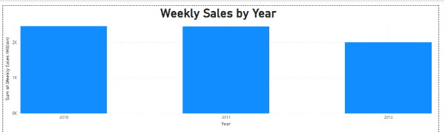

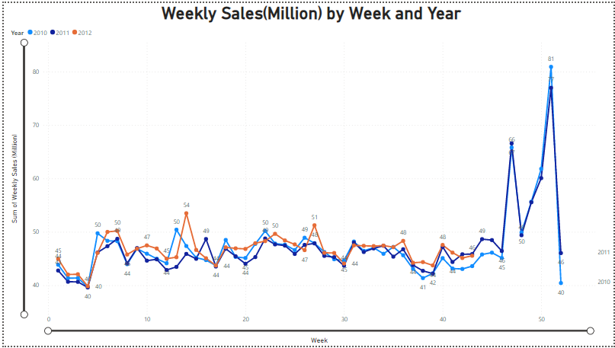

From the graph, it is seen that 2011 has lower sales than 2010 generally. When we look at the mean sales it is seen that 2010 has higher values, but 2012 has no information about November and December which have higher sales. Despite of 2012 has no last two months sales, it's mean is near to 2010. Most probably, it will take the first place if we get 2012 results and add them.

Walmart’s store weekly sales ranges from $209 thousand to $3.8 million. About half of the 45 Walmart stores have weekly sales greater than or equal to $960 thousand.

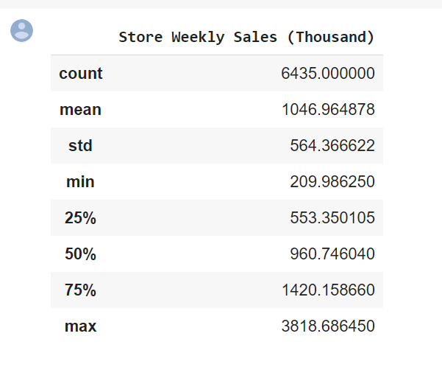

The department's weekly average sales range from -$7,682 to $75204,870. The negative values in weekly sales indicates returns exceed sales in the department store. About half of Walmart's department stores have sales greater than or equal to $7440,682.

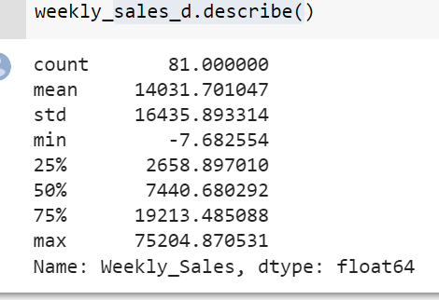

**Negative Weekly Sales:**

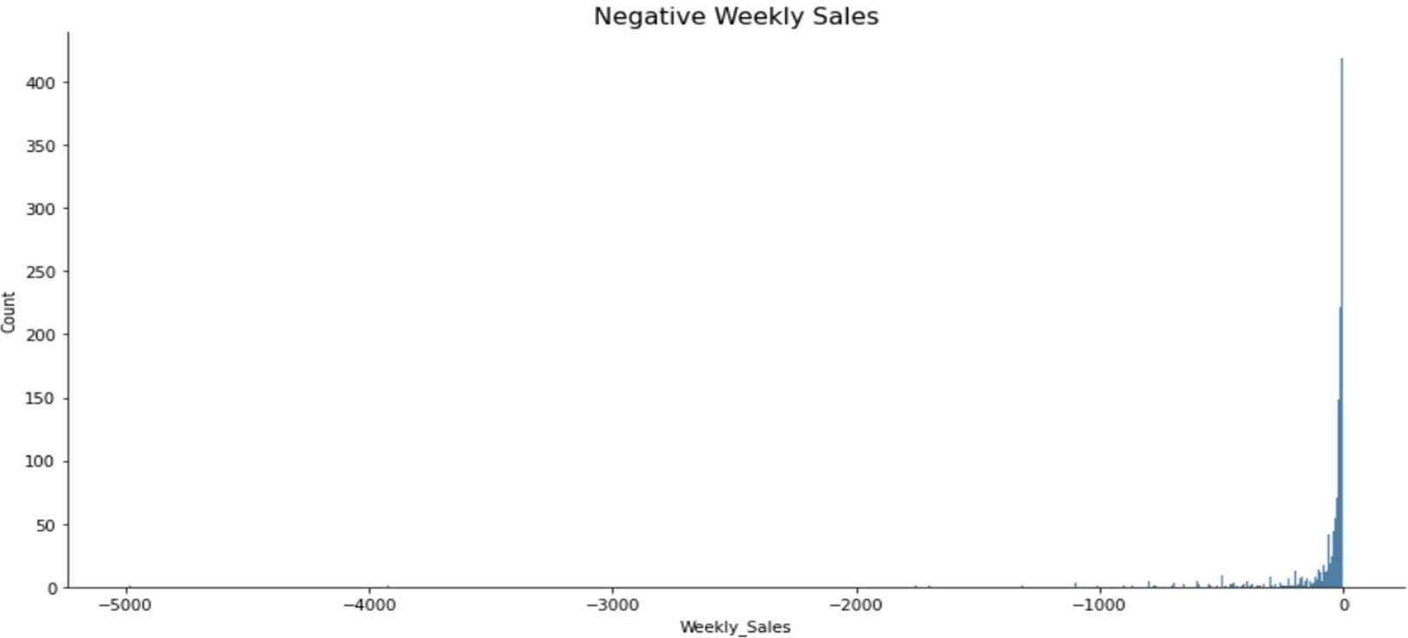

In Below Graph, we can see average monthly sales are highest in December and lowest in January. When we look at the graph above, the best sales are in December and November, as expected. The highest values are belonging to Thanksgiving holiday but when we take average it is obvious that December has the best value.

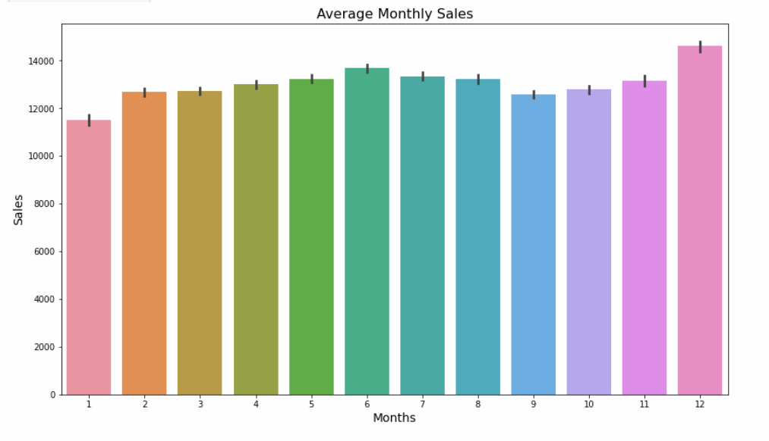

In Below figure, we have average sales per store in which we can see top 5 stores are 20,14,4,2,13 having maximum sales and stores 3,5,29,33,44 have lowest sales.

**Avg Yearly Sales (Million) by Store**

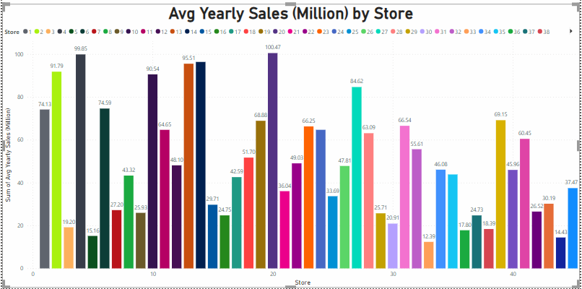

**Average Yearly Sales**

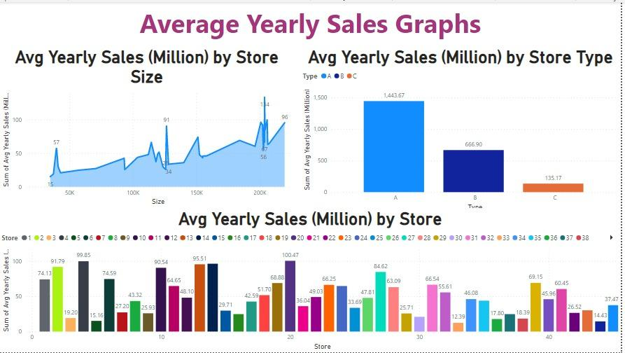

**Weekly Sales by Department:**

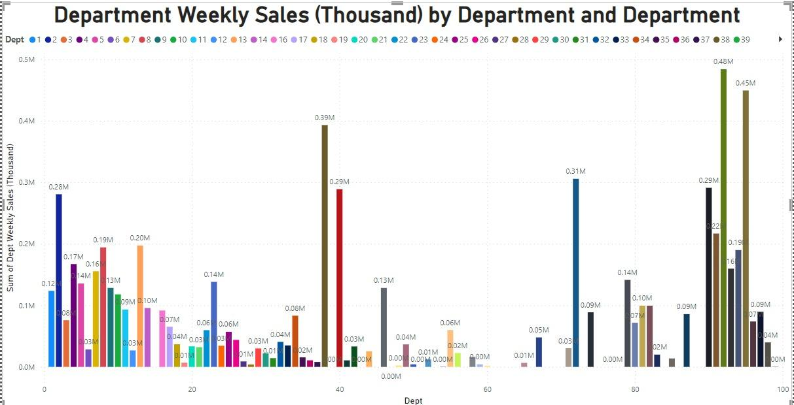

**Temperature Density Plot**

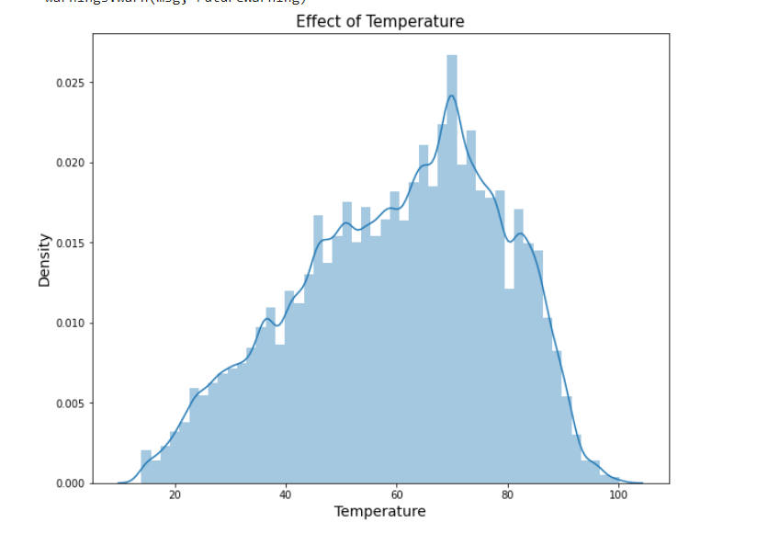

In this Chart, we can see that most of the sales are likely to be between 40-90o Fahrenheit. And maximum sales are near 70o Fahrenheit.

**Sales by Holiday**

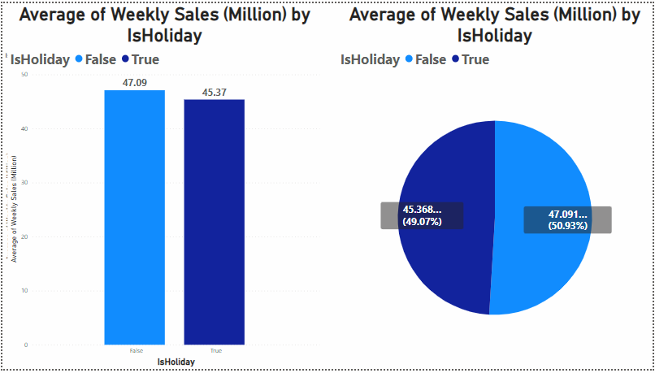

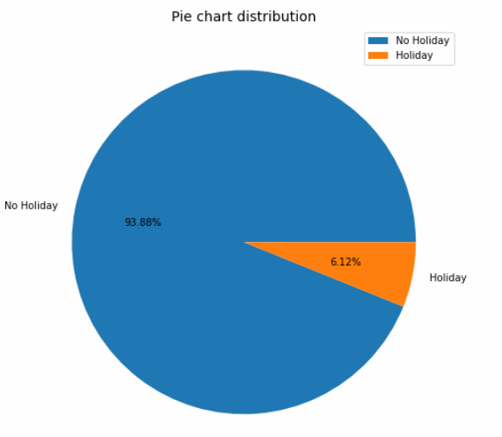

Weeks with holiday are 6.12% and Weeks without holiday 93.88%. Still holiday average sales are almost equal to sales on non-holiday weeks.

Walmart stores are classified into 3 types: A (22 stores), B (17 stores), and C (6 stores).

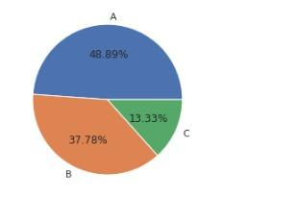

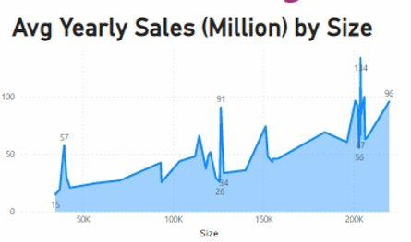

Most type A stores seems to be in a group that have highest average yearly sales. Most type C stores appears to be in a group that have lowest average yearly sales. Most type B stores’ average yearly sales are higher than type C stores’ average yearly sales and lower than type A stores’ average yearly sales.

**Multivariate Data Analysis:**

The heatmap bellow shows that there is not a strong correlation between the following variables:

* Store weekly sales and temperature
* Store weekly sales and fuel price
* Store weekly sales and CPI
* Store weekly sales and unemployment
* Store weekly sales and weekly markdown

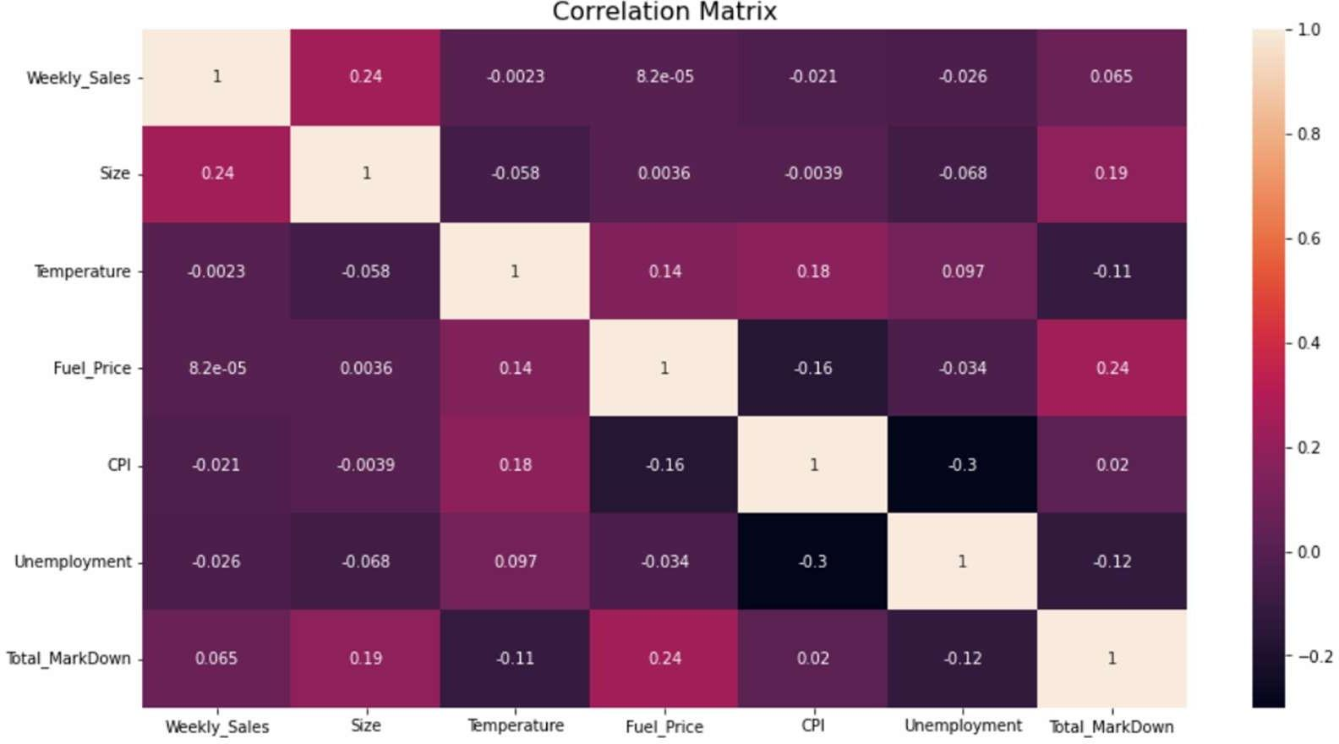

Correlation of features with weekly sales

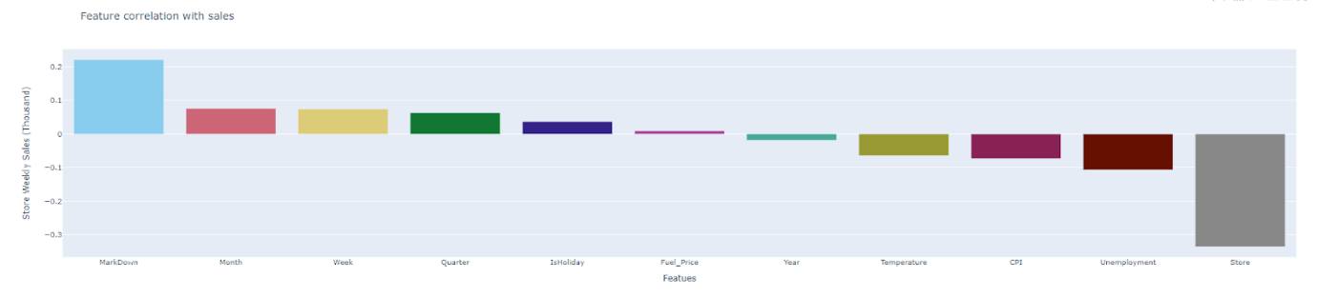

Markdown, Date (Month, week, Quarter) and Isholiday, fuel price has positive correlation with sales.

Year, Temperature, CPI, Unemployment and store has negative correlation with weekly sales.

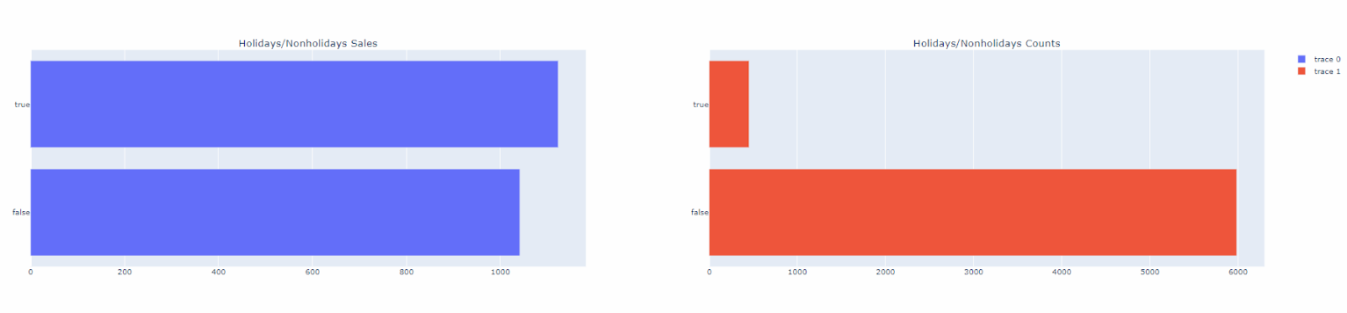

Only 7 percent of the weeks in the data are the holiday weeks Despite being the less percentage of holiday weeks the sales in the holiday’s week are on the average higher than in the non-holiday weeks.

**Conclusion On EDA:**

Walmart’s stores are classified into three types: A, B, and C. Type A stores often have high sales, big store’s sizes, large number of departments, and large markdown values. Type C stores often have low sales, small store sizes, small number of departments, and small.

markdown values. Walmart’s sales are often at peak during the week of Thanksgiving and three weeks after Thanksgiving. External factors like temperature, fuel price, consumer price index, and unemployment rate do not have a significant impact on Walmart’s sales. Promotional

Markdown events before holidays seem to increase Walmart’s sales except for Christmas.

**5 FUTURE IMPROVEMENTS**

More data with no missing values can be useful and will increase the model accuracy.

More detailed feature engineering and feature selection can be done.

More data can be found to observe holiday effects on sales and different holidays will be added like Easter, Halloween and Come Back to School times.

Markdown effects on model can be improved according to department sales. Different models can be built for special stores or departments.

Market basket analysis can be done to find higher demand items of departments.

**6 MODEL TESTING**

1. **Linear Regression:**

Linear regression analysis is used to predict the value of a variable based on the value of another variable. The variable you want to predict is called the dependent variable. The variable you are using to predict the other variable's value is called the independent variable.

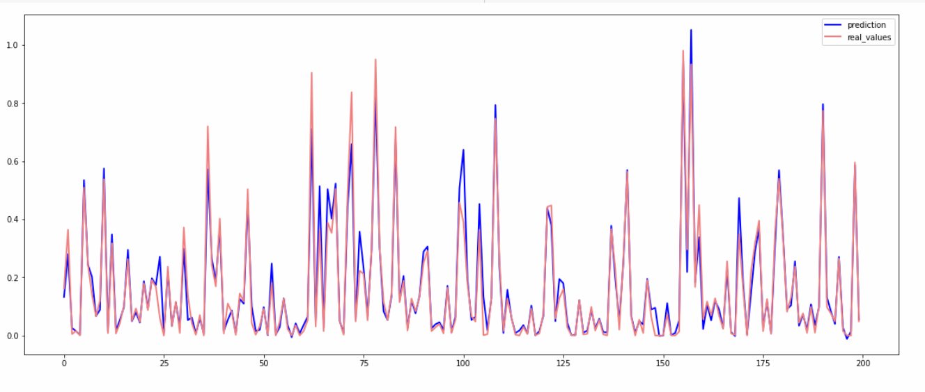

In this linear regression model, we got an accuracy is equal to 92.28%

MAE 0.03005771492151418

MSE 0.0034851431916206573

RMSE 0.05903510135182845

R2 0.9228079866096734

1. **Random Forest Regression:**

Random Forest Regression is a supervised learning algorithm that uses ensemble learning method for regression. Ensemble learning method is a technique that combines predictions from multiple machine learning algorithms to make a more accurate prediction than a single model.

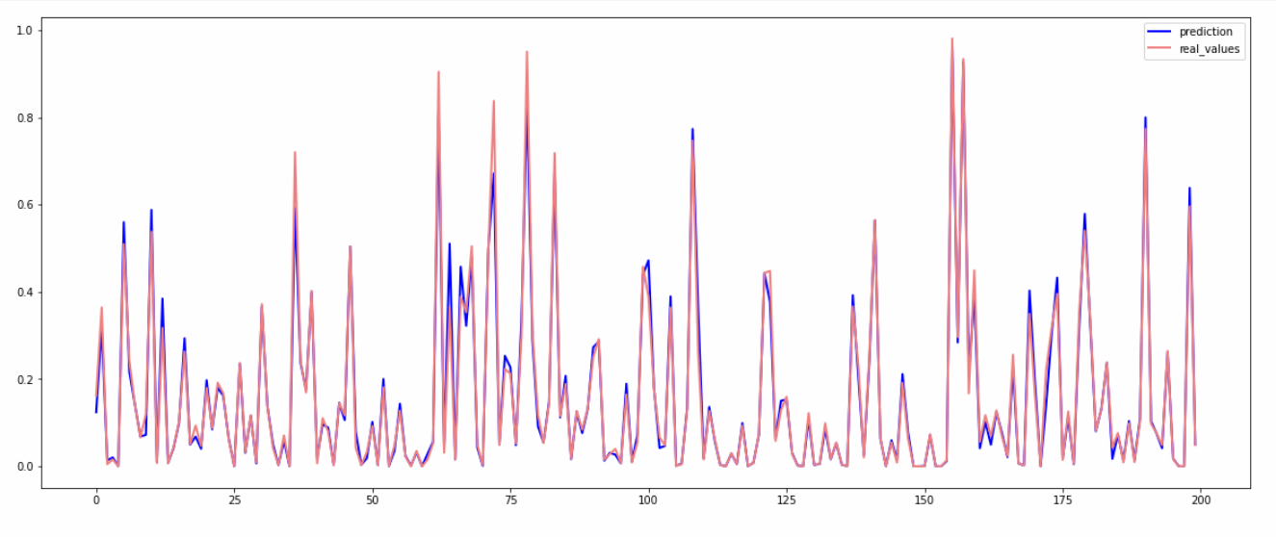

In this model we got an accuracy is equal to 97.90%

MAE 0.015497700214673305

MSE 0.0009441195875861165

RMSE 0.030726529052044205

R2 0.9790892409415295

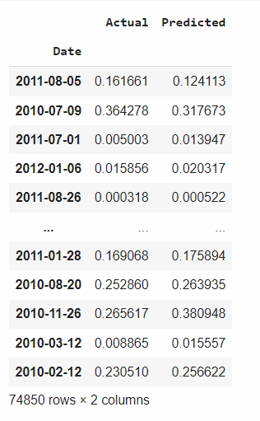

1. **K Neighbors Regressor Model:**

KNN regression is a non-parametric method that, in an intuitive manner, approximates the association between independent variables and the continuous outcome by averaging the observations in the same neighborhood. The size of the neighborhood needs to be set by the analyst or can be chosen using cross-validation (we will see this later) to select the size that minimizes the mean-squared error.

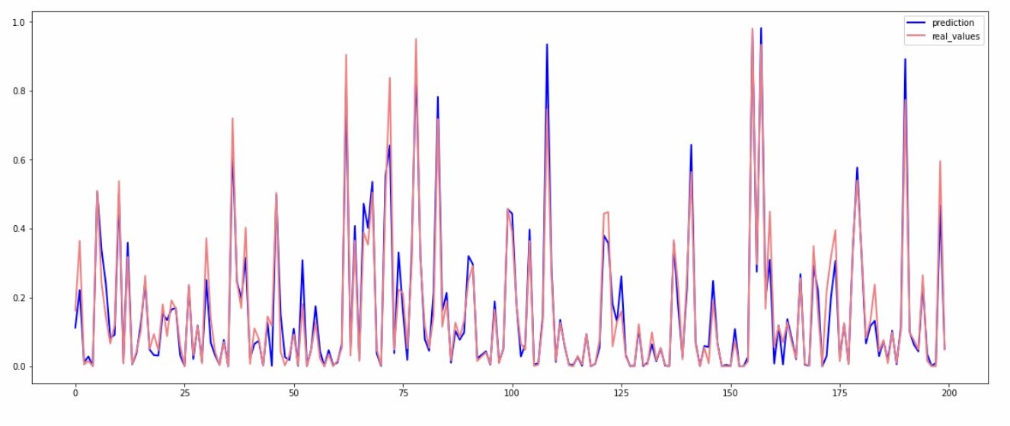

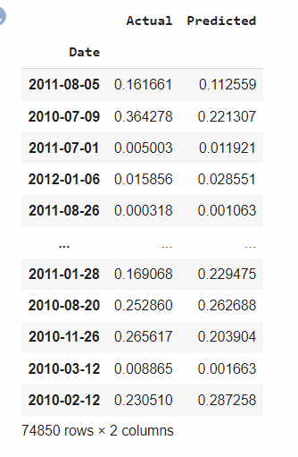

In this model we got an accuracy is equal to 91.97%

MAE 0.03312215784495987

MSE 0.003624289652612284

RMSE 0.060202073490971085

R2 0.9199211027805663

1. **XGboost Model:**

XGBoost, which stands for Extreme Gradient Boosting, is a scalable, distributed gradient- boosted decision tree (GBDT) machine learning library. It provides parallel tree boosting and is the leading machine learning library for regression, classification, and ranking problems.

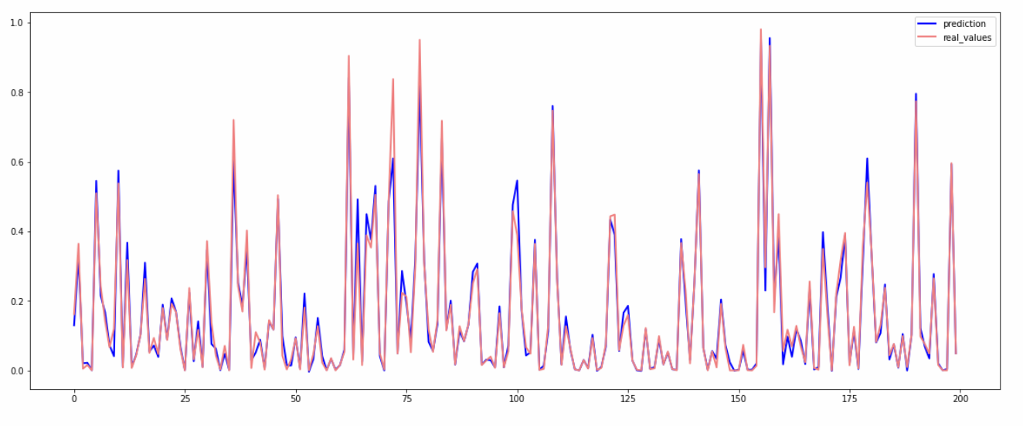

In this model we got an accuracy is equal to 97.28%

MAE 0.019863883311422855

MSE 0.0012266346907320747

RMSE 0.03502334493922696

R2 0.9728314959830722

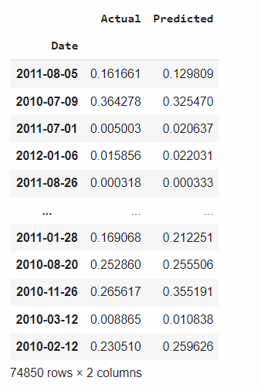

1. **Custom Deep Learning Neural Network:**

A neural network is a method in artificial intelligence that teaches computers to process data in a way that is inspired by the human brain. It is a type of machine learning process, called deep learning, that uses interconnected nodes or neurons in a layered structure that resembles the human brain.

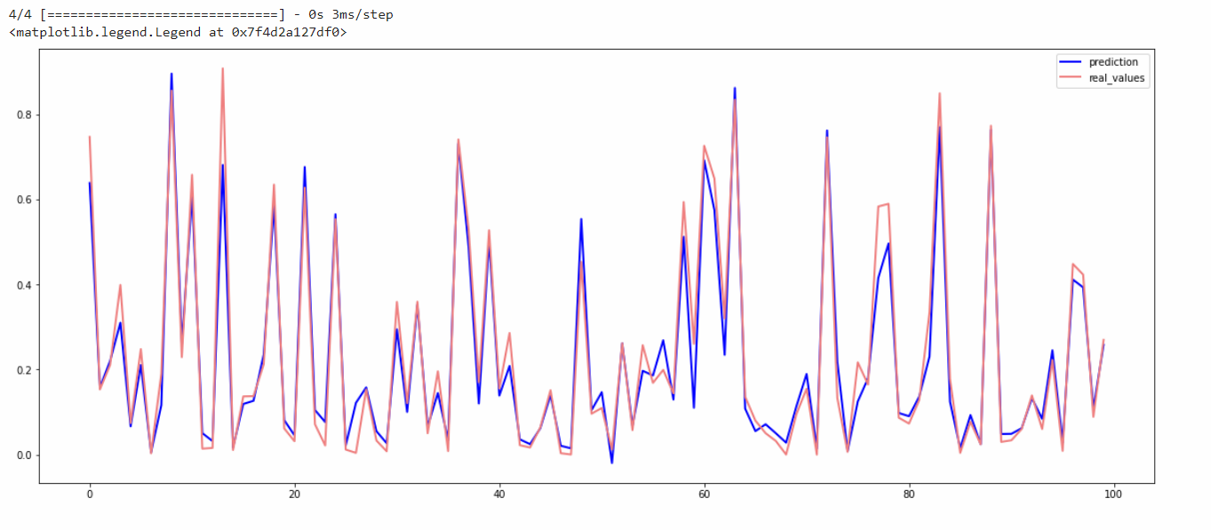

In this model we got an accuracy is equal to 97.17%

MAE 0.034005930661177824

MSE 0.003993838791591234

RMSE 0.0631968258031306

R2 0.9119278490383779

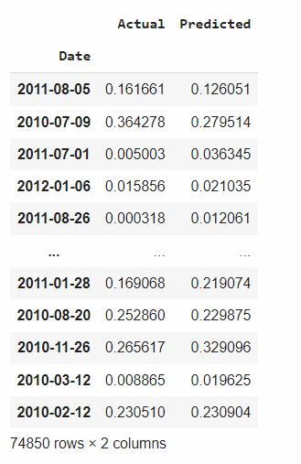

**7 COMPARING MODELS**

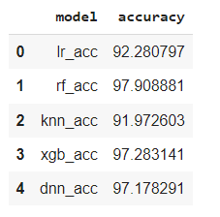

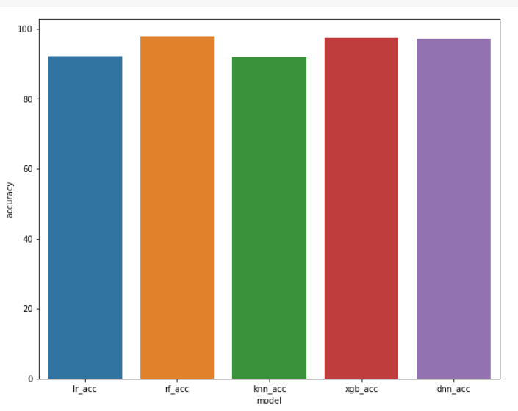

From the above figures we can see that the random **forest regression** model has the highest accuracy Which is **97.90 %.** So, we will use random forest regression model for sales prediction of this Walmart datasets other models also perform well as their accuracies are:

* Linear regression = 97.28 %
* KNN Regression = 91.97 %
* XGBoost regression = 97.28 %
* Deep Learning Neural Network=97.17%

**Sales Forecast using Power BI:**

Forecasting in Power View is based on an established suite of methods for time series prediction called exponential smoothing. The exponential smoothing method has a good track record in both academia and business, and has the advantage that it suppresses noise, or unwanted variation that can distort the model, while efficiently capturing trends. Power View uses the appropriate model automatically when we start a forecast for our line chart, based on an analysis of the historical data. The graph plotted below is between weekly sales and year. Here we are forecasting for next 6 months (from 4 October 2012 to 2 April 2013)

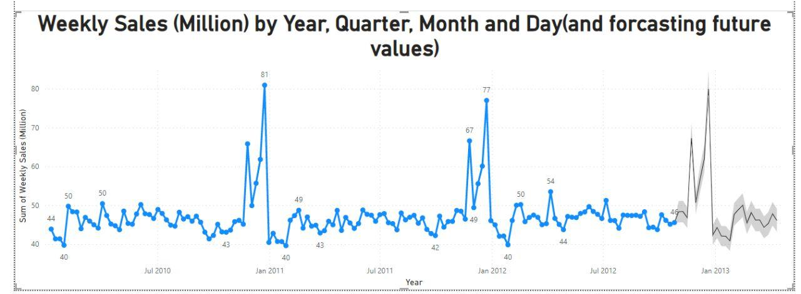

**8 CONCLUSION**

In conclusion, we find that our regression equation is quite accurate (97.17% accuracy) in predicting the weekly sales with Random Forest Regressor. Walmart can use it to forecast the sales better. They need to overhaul the markdowns that are given currently as they are not having the intended impact on sales. They need to focus on the year-end inventory as December month plays a crucial part in predicting sales.

**REFERENCES**

Dataset link:

https://[www.kaggle.com/datasets/divyajeetthakur/walmart-sales-prediction](http://www.kaggle.com/datasets/divyajeetthakur/walmart-sales-prediction)

Models:

Linear Regression:

https://scikit-learn.org/stable/modules/linear_model.html#ordinary-least- squares

Random Forest Regression:

https://scikit-learn.org/stable/modules/ensemble.html#forests-of-randomized- trees

KNN regression:

https://scikit-learn.org/stable/modules/neighbors.html#nearest-neighbors- regression

XGBoost regression:

<https://xgboost.readthedocs.io/en/latest/index.html>

Deep Learning Neural Network:

<https://www.tensorflow.org/tutorials/keras/regression>